DOKUZ EYLUL UNIVERCITY

Faculty of Engineering

Electrical and Electronics Engineering

**EED 1005 Introduction to Programming Laboratoary#6**

Student Name : Yavuz BALI Number:2014502021

**Laboratoary Work:**

**Task 1:**

#include<stdio.h>

int triangular_number(int n){

int results;

results=(n*(n+1))/2;

return results; }

int main(){

int a,i=1;

while(i==1) {

printf("Enter a integear : "); scanf("%d",&a);

printf("Triangular number %d is %d \n\a",a,triangular_number(a)); }

return 0; }

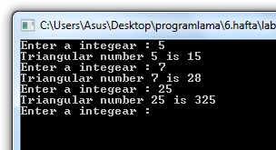

**Task 2:**

#include<stdio.h>

int fact(int b){

int i,result1=1;

for(i=1;i<=b;i++){

result1=result1*i; }

return result1; }

void function_binomial(int n) {

int C,r,i,x,j;

for(i=0;i<=n;i++){

x=n-i;

for(j=1;j<=x;j++){

printf(" "); }

for(r=0;r<=i;r++) {

C=fact(i)/(fact(r)*fact((i-r)));

printf("%d ",C); }

printf("\n"); } }

int main() {

int a,i=1;

while(i==1){

printf("Enter a integear number:"); scanf("%d",&a);

function_binomial(a); } }

